A&S Online Declaration Form (DOCUSIGN)
Guide for Prospective Cognitive Science Majors

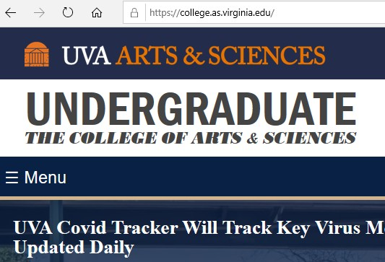

Go to: https://college.as.virginia.edu

Go to: MENU
Go to: FORMS

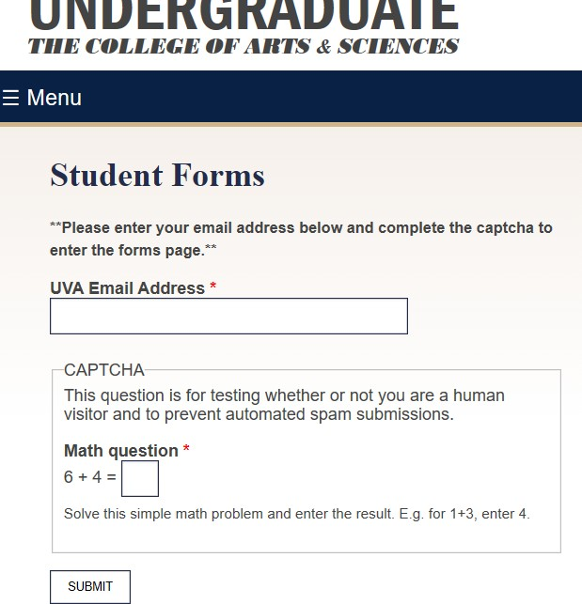

Navigate CAPTCHA gateway

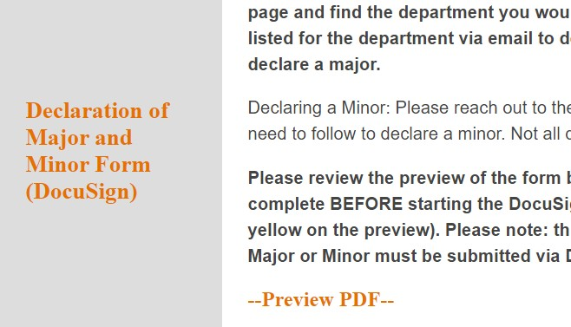

Click on: DECLARATION OF MAJOR AND
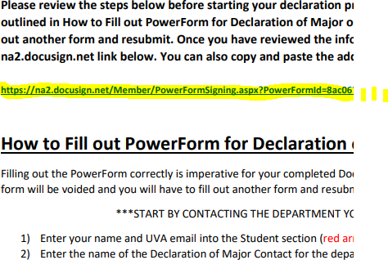MINOR FORM (DOCUSIGN)

Go to: POWERFORM
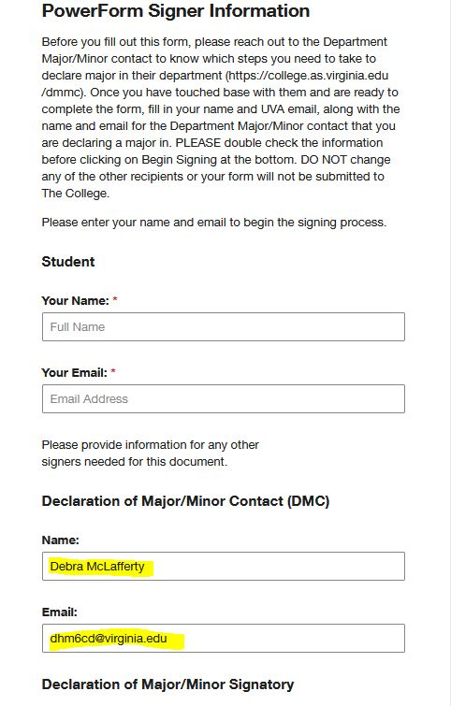
Navigate POWERFORM:
In Student section, enter your FULL NAME and EMAIL ADDRESS

In Declaration of Major Contact (DMC) section, enter:
Debra McLafferty
dhm6cd@virginia.edu

Do not fill in any of the other sections.

Click on (bottom of the PowerForm page

Complete DECLARATION FORM:

            - Enter Identifying Information
            - Enter declaration major/minor name: Cognitive Science-COGS Concentration Area
              - Be sure and add ONE of the five concentrations—computer science, linguistics, philosophy, psychology, or neuroscience
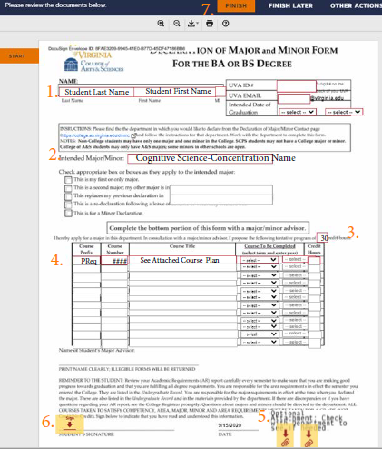
b.Check appropriate box for major.

3.Enter 30 or higher in credit hour box.
4. COURSE SECTION:
disregard the instructions to “complete with a major advisor”
list only your first COGS class Prefix and Number and in the “Title” Section fill in See Attached Course Plan
5. Attach C Major Planning Form
Attach advising transcript available in SIS: https://registrar.virginia.edu/transcript/unofficial-transcript

6. Sign digitally by clicking yellow tab

7.Click FINISH at Top or Bottom of Form

